|  |
| --- |
|  |
| Capstone Project Document |

**Vietnamese Medicinal Plants Network**

Report #2 – Class Design

|  |  |  |
| --- | --- | --- |
| **Vietnamese Medicinal Plants Network** | | |
| **Group Members** | Nguyễn Minh Tiến | SE02545 |
| Trần Bình Khánh | SE02764 |
| Nguyễn Hải Đăng | SE02992 |
| Hoàng Thị Quỳnh | SE02639 |
| **Supervisor** | Mr. Nguyễn Văn Sang | |
| **Project code** | VMN | |

**- Hanoi, 03/2016 -**

# SIGNATURE PAGE

AUTHOR: Nguyễn Hải Đăng 28/03/2016

Team member

REVIEWERS: Nguyễn Minh Tiến 30/03/2016

Project manager

APPROVAL: Nguyễn Văn Sang --/--/--16

Supervisor

Record of change

*A - Added M - Modified D – Deleted

|  |  |  |  |  |  |
| --- | --- | --- | --- | --- | --- |
| Effective Date | Changed Item | A,M,D | Change Description | Reason for Change | Rev. Number |
| 28/March/2016 | Create Class Design | A | First version | Create Class Design | 1.0 |
|  |  |  |  |  |  |
|  |  |  |  |  |  |
|  |  |  |  |  |  |
|  |  |  |  |  |  |
|  |  |  |  |  |  |
|  |  |  |  |  |  |
|  |  |  |  |  |  |
|  |  |  |  |  |  |
|  |  |  |  |  |  |
|  |  |  |  |  |  |
|  |  |  |  |  |  |
|  |  |  |  |  |  |

TABLE CONTENTS

SIGNATURE PAGE 1

Introduction 4

1.1 Purpose 4

1.2 Definitions, Acronyms and Abbreviations 4

2 Package 4

2.1 Package Diagram 4

2.2 Package Description 5

2.2.1 Model 5

2.2.2 View 10

2.2.3 Middleware 10

2.2.4 Controller 13

3 Function 16

3.1 Auth 16

3.1.1 Class diagram 16

3.1.2 Login 16

3.1.3 Logout 16

3.2 Register 17

3.2.1 Class Diagram 17

3.2.2 Sequence Diagram 18

3.3 Profile 19

3.3.1 Class Diagram 19

3.3.2 Sequence Diagram 19

3.4 Contribute article 20

3.4.1 Class Diagram 20

3.4.2 Sequence Diagram 20

3.5 Edit article 21

3.5.1 Class Diagram 21

3.5.2 Sequence Diagram 21

3.6 Report 22

3.6.1 Class Diagram 22

3.6.2 Sequence Diagram 22

3.7 Review 23

3.7.1 Class Diagram 23

3.7.2 Sequence Diagram 24

3.8 Admin Proceed 24

3.8.1 Class Design 24

3.8.2 Sequence Diagram 25

3.9 Mod Proceed 25

3.9.1 Class Design 25

3.9.2 Sequence Diagram 26

# Introduction

## Purpose

Vietnamese Medicinal Plants Network class design document contains descriptions of all classes of the Vietnamese Medicinal Plants Network. It includes: Class diagrams that describe the static relation of all classes in the system.

## Definitions, Acronyms and Abbreviations

|  |  |  |
| --- | --- | --- |
| Abbreviations | Description | Comment |
| VMN | Vietnamese Medicinal Plants Network |  |
| FAQ | Frequently Asked Question |  |

1. Definitions, Acronyms and Abbreviations

# Package

## Package Diagram

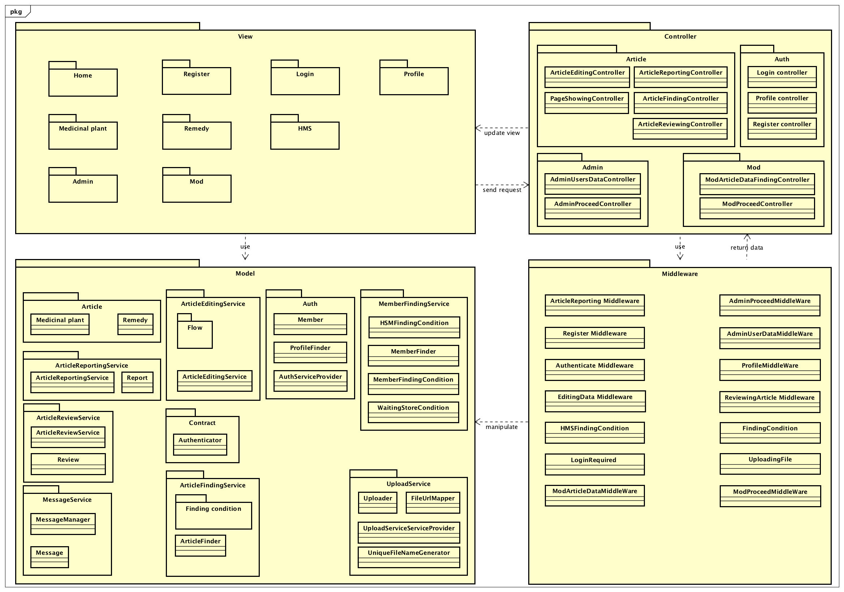

1. Package Diagram

## Package Description

### Model

#### Article

##### 2.2.1.1.1 Medicinal Plant Model

|  |  |  |  |  |  |
| --- | --- | --- | --- | --- | --- |
| **No** | **Field Name** | **Type** | **Default** | **Note** | **Description** |
|  | commonName | String | Not Null |  | Common name of medicinal plant |
|  | otherName | String | Null |  | Other name of medicinal plant |
|  | ScienceName | String | Null |  | Science name of medicinal plant |
|  | Location | String | Null |  | Location of medicinal plant |
|  | Description | String | Not Null |  | Description of medicinal plant |
|  | ratingPoint | int | 0 |  | Rating point of medicinal plant |
|  | utility | String | Not Null |  | Utility of medicinal plant |
|  | thumbnailUrl | String | Null |  | Link to thumbnail image |
|  | author | String | Not Null |  | Medicinal plant article contributor |
|  | imgUrl | String | Null |  | Image link of medicinal plant |
|  | id | int |  | Auto increment | Id of medicinal plant |

1. Medicinal Plant model

##### Remedy Model

|  |  |  |  |  |  |
| --- | --- | --- | --- | --- | --- |
| **No** | **Field Name** | **Type** | **Default** | **Note** | **Description** |
|  | title | String | Not null |  | Title of remedy article |
|  | description | String | Not Null |  | Description in remedy article |
|  | note | String | Null |  | Note in remedy |
|  | usage | String | Not null |  | How to use |
|  | ratingPoint | int | 0 |  | Rating point of remedy article |
|  | utility | String | Not null |  | Utility of remedy article |
|  | thumbnailUrl | String | Null |  | Link to thumbnail image |
|  | author | String | Not null |  | Remedy article contributor |
|  | imgUrl | String |  |  | Image link of remedy article |
|  | id | int |  | Auto increment | Id of remedy article |

1. Remedy model

#### Auth

#### 2.2.1.2.1 Authenticator

|  |  |  |  |  |  |
| --- | --- | --- | --- | --- | --- |
| **No** | **Properties** | **Type** | **Default** | **Note** | **Description** |
|  | Credential | Object |  |  | Authentic tasks |
|  | Hasher | Object |  |  | Create password |
|  | Key | String |  |  |  |

1. Authenticator properties

|  |  |  |  |  |
| --- | --- | --- | --- | --- |
| No | Method | Parameter | Return | Description |
|  | setPrivateKey | key |  | Set private key |
|  | byPassword | Email, password | foundCredential | Check password for authentic task |

1. Authenticator

##### Member Model

|  |  |  |  |  |  |
| --- | --- | --- | --- | --- | --- |
| **No** | **Field Name** | **Type** | **Default** | **Note** | **Description** |
|  | accountName | String | Not null |  | Member account |
|  | firstName | String | Null |  | First name |
|  | lastName | String | Null |  | Last name |
|  | DoB | String | Null |  | Date of birth |
|  | email | String | Not null |  | Email |
|  | avatar | String | Null |  | Avatar |

1. Member Model

#### Article edit service

|  |  |  |  |  |
| --- | --- | --- | --- | --- |
| No | Method | Parameter | Return | Description |
|  | Edit | editorFlowManager, type | EditorFlow | Edit an article |
|  | Add | editorFlowManager, type | EditorFlow | Add an article |

1. Article edit service

#### MemberFlow Model

|  |  |  |  |  |
| --- | --- | --- | --- | --- |
| No | Method | Parameter | Return | Description |
|  | proceed | Article, type |  | Log article |

1. MemberFlow Model

#### ModFlow Model

|  |  |  |  |  |
| --- | --- | --- | --- | --- |
| No | Method | Parameter | Return | Description |
|  | proceed | Article, type |  | Log and save article to database |

1. ModFlow Model

#### ArticleFindingService

|  |  |  |  |  |
| --- | --- | --- | --- | --- |
| No | Method | Parameter | Return | Description |
|  | getQuery | Article, type |  | Find article |

1. Article finding service

#### ArticleReportingService

#### 2.2.1.7.1 Report Class

|  |  |  |  |  |  |
| --- | --- | --- | --- | --- | --- |
| **No** | **Properties** | **Type** | **Default** | **Note** | **Description** |
|  | Reason | String |  |  | Reason of report |
|  | Reporter | String |  |  | Reporter who reported article |
|  | Reported | String |  |  | Article Reported |

1. Report

#### 2.2.1.7.2 ArticleReportingService

|  |  |  |  |  |
| --- | --- | --- | --- | --- |
| No | Method | Parameter | Return | Description |
|  | reportPlant | Report |  | Insert reported information to database |

#### ArticleReviewService

#### 2.2.1.8.1 Review Model

|  |  |  |  |  |  |
| --- | --- | --- | --- | --- | --- |
| **No** | **Properties** | **Type** | **Default** | **Note** | **Description** |
|  | Comment | String |  |  | comments in article |
|  | Rating | int |  |  | Reviewer rates in article |
|  | Reviewer | String |  |  | Reviewer who review article |
|  | Reviewed | int |  |  |  |

1. Review Model

#### Upload Service

#### 2.2.1.9.1 Uploader Model

|  |  |  |  |  |  |
| --- | --- | --- | --- | --- | --- |
| **No** | **Field Name** | **Type** | **Default** | **Note** | **Description** |
|  | fileNameGenerator |  |  |  |  |
|  | fileUrlMapper |  |  |  |  |
|  | uploadDir |  |  |  |  |

1. Uploader Model

|  |  |  |  |  |
| --- | --- | --- | --- | --- |
| No | Method | Parameter | Return | Description |
|  | upload |  | uploader |  |

#### 2.2.1.9.2 UploadServiceServiceProvider

|  |  |  |  |  |
| --- | --- | --- | --- | --- |
| No | Method | Parameter | Return | Description |
|  | register | uploadedFile | fileUrlMapper |  |
|  | provider |  | Uploader, FileUploadValidator |  |

#### 2.2.1.9.2 FileUrlMapper Model

|  |  |  |  |  |
| --- | --- | --- | --- | --- |
| No | Method | Parameter | Return | Description |
|  | setPathTemplate | pathTemplate |  |  |
|  | map | fileName | String |  |

1. FileUrlMapper Model

#### UniqueFileNameGenerator Model

|  |  |  |  |  |
| --- | --- | --- | --- | --- |
| No | Method | Parameter | Return | Description |
|  | generate |  | String |  |

1. Slide Model

### View

Contain many blade.files to display user interface.

### Middleware

Validate data from client request, and make necessary information.

#### ArticleReporting

|  |  |  |  |  |
| --- | --- | --- | --- | --- |
| No | Method | Parameter | Return | Description |
|  | handle | Request, Closure | Closure |  |
|  | buildReportObject | request | report |  |

1. ArticleReporting Middleware

#### Authenticate

|  |  |  |  |  |
| --- | --- | --- | --- | --- |
| No | Method | Parameter | Return | Description |
|  | handle | Request, Closure, guard | Closure | Check authorized, login request. |

1. Authenticate Middleware

#### EditingData

|  |  |  |  |  |
| --- | --- | --- | --- | --- |
| No | Method | Parameter | Return | Description |
|  | handle | Request, Closure | Closure | Handle editing data request |
|  | makeArticleInstance | Request | plantFactory | Contribute or update plant |

1. EditingData Middleware

#### FindingCondition

|  |  |  |  |  |
| --- | --- | --- | --- | --- |
| No | Method | Parameter | Return | Description |
|  | handle | Request, Closure | Closure | Handle condition finding request |
|  | makeSearchCondition | Closure | ArticleFindingCondition | Search to show result of medicinal plant, remedy |

1. FindingCondition Middleware

#### Register

|  |  |  |  |  |
| --- | --- | --- | --- | --- |
| No | Method | Parameter | Return | Description |
|  | Handle | Request, Closure | Closure | Handle register request |
|  | makeMemberInstance | Request | MemberFactory | Create member object |
|  | makeCredentialInstance | Request | credential | Set attribute of member |

1. Register Middleware

#### UploadingFile

|  |  |  |  |  |
| --- | --- | --- | --- | --- |
| No | Method | Parameter | Return | Description |
|  | Handle | Request, Closure | Closure | Handle uploading file request |

1. UploadingFile Middleware

#### ReviewingArticle

|  |  |  |  |  |
| --- | --- | --- | --- | --- |
| No | Method | Parameter | Return | Description |
|  | Handle | Request, Closure | Closure | Handle review article |
|  | buildReviewObject | Request | Review | Build review object, which has comment, rate information. |

1. ReviewingArticle Middleware

### Controller

#### ArticleEditingController

|  |  |  |  |  |
| --- | --- | --- | --- | --- |
| No | Method | Parameter | Return | Description |
|  | addPlants | Plant, editorFlowManager | http response | Add medicinal plant, show message when successful. |
|  | editPlants | Plant, editorFlowManager | http response | Edit medicinal plant, show message when successful. |
|  | addRemedy | Remedy, editorFlowManager | http response | Add remedy, show message when successful. |
|  | editRemedy | Remedy, editorFlowManager | http response | Edit remedy, show message when successful. |

1. Article Editing Controller

#### ArticleFindingController

|  |  |  |  |  |
| --- | --- | --- | --- | --- |
| No | Method | Parameter | Return | Description |
|  | findPlants | MedicinalPlantNameCondition | view | Search medicinal plant |
|  | medicinalPlantsDetail | MedicinalPlantsIdCondition | view | Show medicinal plant detail |
|  | showAdvanceSearchPlant | AdvanceSearchPlantsCondition | view | Advance search plant |
|  | findRemedies | RemediesKeywordCondition | view | Search remedy |
|  | detailRemedy | RemedyDetailCondition | view | Show remedy detail |
|  | showAdvanceSearchRemedy | AdvanceSearchRemediesCondition | view | Show advance search remedy |

1. ArticleFinding Controller

#### ArticleReportingController

|  |  |  |  |  |
| --- | --- | --- | --- | --- |
| No | Method | Parameter | Return | Description |
|  | reportPlant | Report | http response | Report medicinal plant and show message after send report |

1. ArticleReporting Controller

#### ArticleReviewingController

|  |  |  |  |  |
| --- | --- | --- | --- | --- |
| No | Method | Parameter | Return | Description |
|  | reviewPlants | Report | http response | Review medicinal plant |

1. ArticleReviewing Controller

#### PageShowingController

|  |  |  |  |  |
| --- | --- | --- | --- | --- |
| No | Method | Parameter | Return | Description |
|  | home |  | View | Display homepage |
|  | showAddPlant |  | View | Display add plant page |
|  | showEditPlant |  | View | Display edit plant page |

1. Page showing Controller

#### LoginController

|  |  |  |  |  |
| --- | --- | --- | --- | --- |
| No | Method | Parameter | Return | Description |
|  | showLogin |  | View | Show login page |
|  | doLogin |  | http response | Check login and redirect to homepage |
|  | doLogout |  | http response | Check logout and redirect to homepage |

1. Login Controller

#### RegisterController

|  |  |  |  |  |
| --- | --- | --- | --- | --- |
| No | Method | Parameter | Return | Description |
|  | memberRegister | Credential, Member | http response | Register as member of system |
|  | storeRegister | Credential, HerbalMedicineStore | http response | Register as herbal medicine store |

1. Register Controller

#### ProfileController

|  |  |  |  |  |
| --- | --- | --- | --- | --- |
| No | Method | Parameter | Return | Description |
|  | showMemberProfile |  | view | Show member profile |

1. Profile Controller

#### AdminUsersDataController

|  |  |  |  |  |
| --- | --- | --- | --- | --- |
| No | Method | Parameter | Return | Description |
|  | adminHome |  | view | Show admin dashboard |
|  | adminGetApprove | WaitingStoreCondition | view | Get all register as Herbal medicine store |
|  | adminAllUsers | AllUserCondition | view | Get list of all user |
|  | adminStoreInfo | MemberInformationCondition | view | Get store information |
|  | adminUserDetail | MemberInformationCondition | view | Get user detail |

1. Admin user data Controller

#### AdminProceedController

|  |  |  |  |  |
| --- | --- | --- | --- | --- |
| No | Method | Parameter | Return | Description |
|  | approveRegister | credential | http response | Approve register as Herbal medicine store |
|  | denyRegister | credential | http response | Deny register as Herbal medicine store |
|  | changeStatus | credential | http response | Active or inactive a credential |
|  | changeRole | credential | http response | Change role |

1. Admin proceed Controller

#### ModArticleDataFindingController

|  |  |  |  |  |
| --- | --- | --- | --- | --- |
| No | Method | Parameter | Return | Description |
|  | modHome |  | view | Show the mod dashboard |
|  | getWaitingPlants | PlantManagementCondition | view | Get waiting plants |
|  | getWaitingRemedies | RemedyManagementCondition | view | Get waiting remedy |

1. Mod Article Data Finding Controller

#### ModProceedController

|  |  |  |  |  |
| --- | --- | --- | --- | --- |
| No | Method | Parameter | Return | Description |
|  | approveNewPlant | MedicinalPlant | http response | Approve new plant |
|  | approveEditedPlant | MedicinalPlant | http response | Approve edited plant |
|  | denyPlant |  | http response | Reject medicinal plant |
|  | approveNewRemedy | Remedy | http response | Approve new remedy |
|  | approveEditRemedy | Remedy | http response | Approve edit remedy |
|  | rejectRemedy |  | http response | Reject remedy |
|  | remindPlantAuthor | Message | http response | Send message to remind author’s medicinal plant |
|  | remindRemedyAuthor | Message | http response | Send message to remind author’s remedy |

1. Mod proceed Controller

# Function

## Auth

### Class diagram

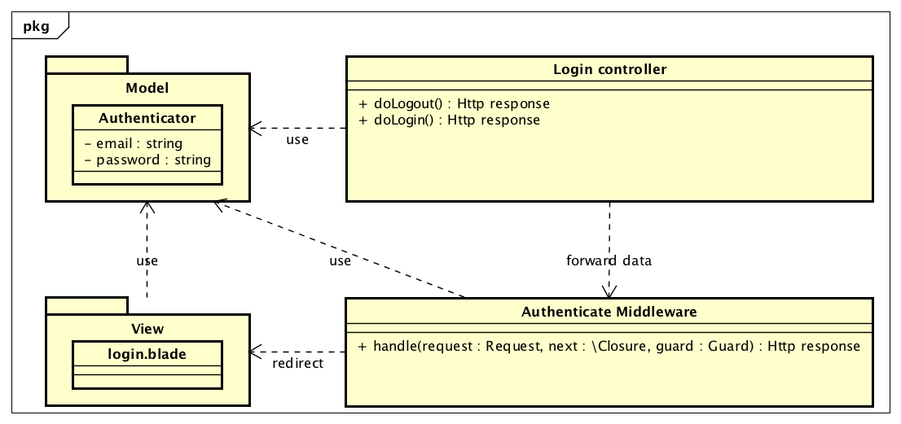

1. Auth class diagram

### Login

#### Sequence diagram

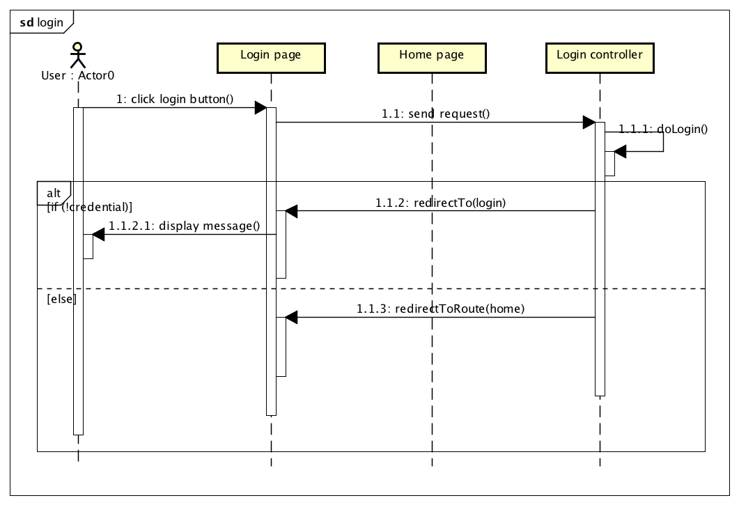

1. Login sequence diagram

### Logout

#### Sequence Diagram

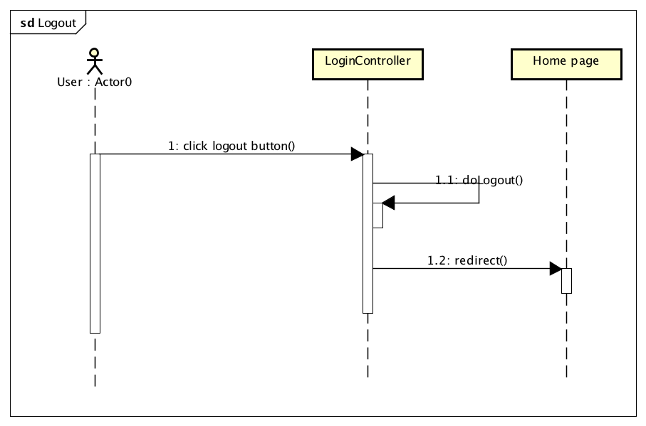

1. Logout sequence diagram

## Register

### Class Diagram

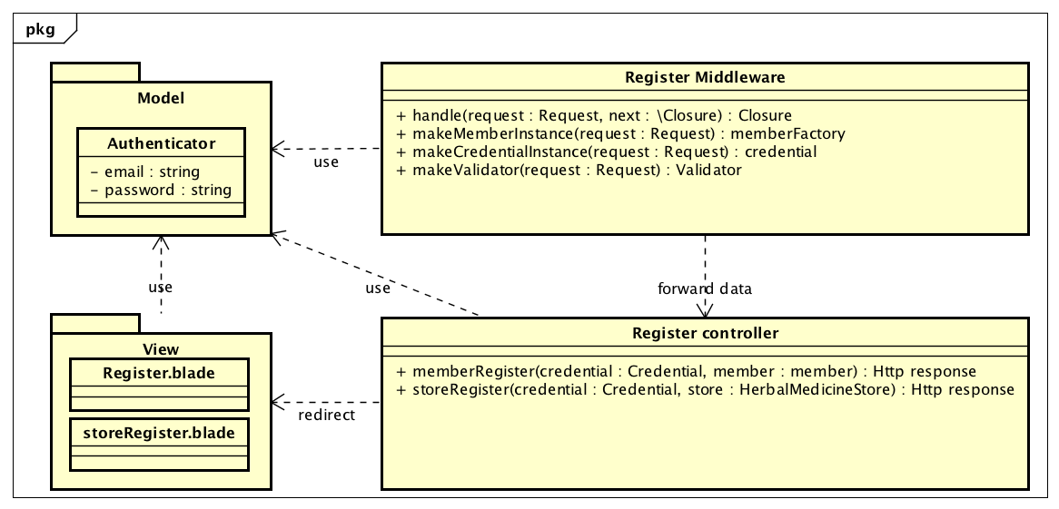

1. Register class diagram

### Sequence Diagram

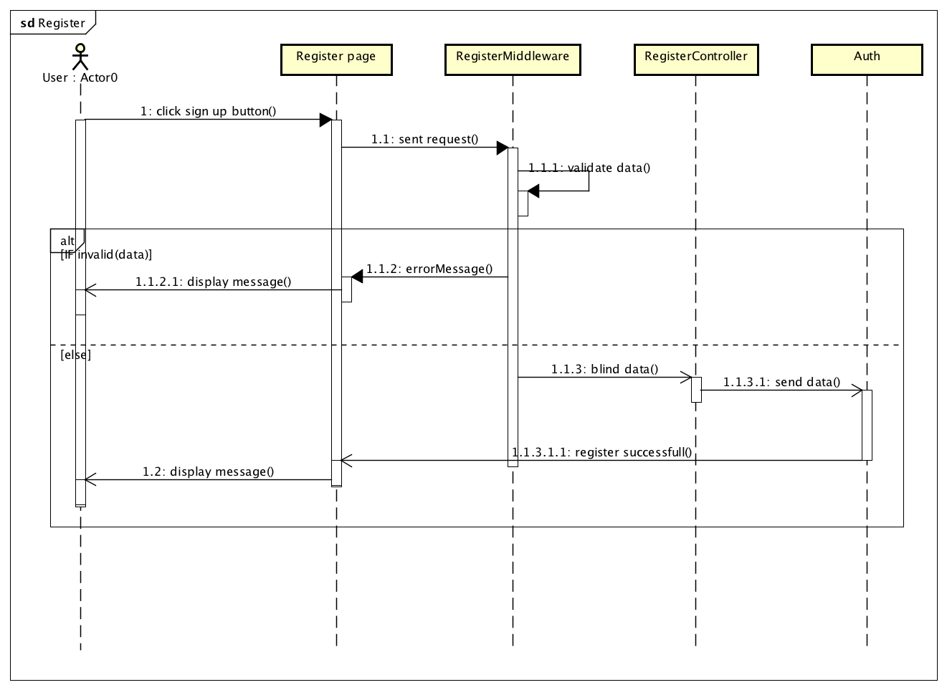

1. Register sequence diagram

## Profile

### Class Diagram

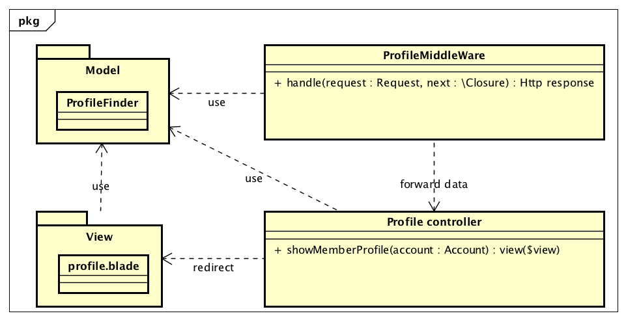

1. Profile class diagram

### Sequence Diagram

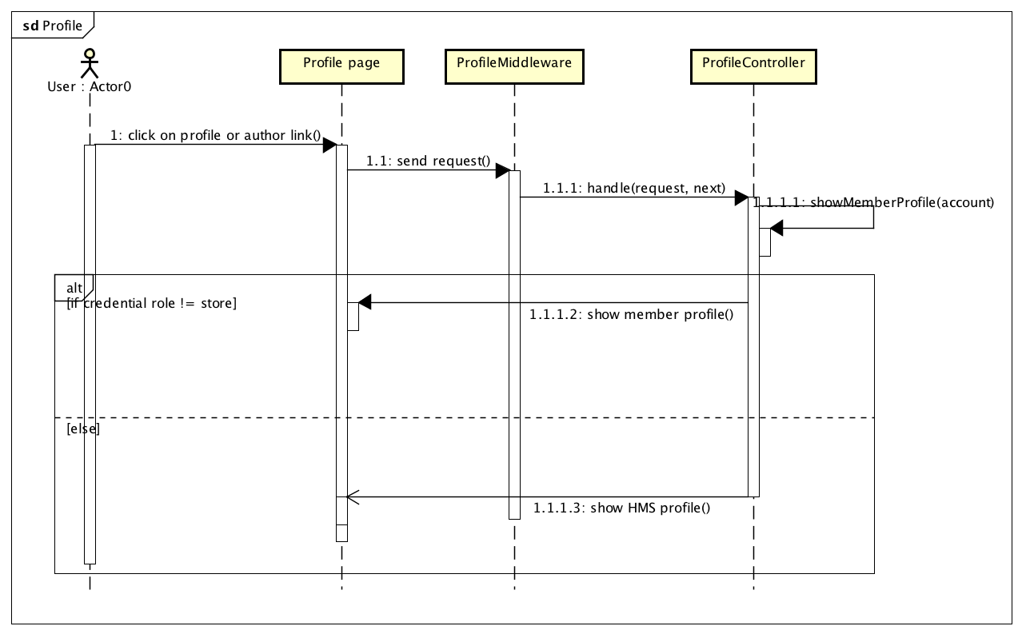

1. Profile sequence diagram

## Editing article

### Class Diagram

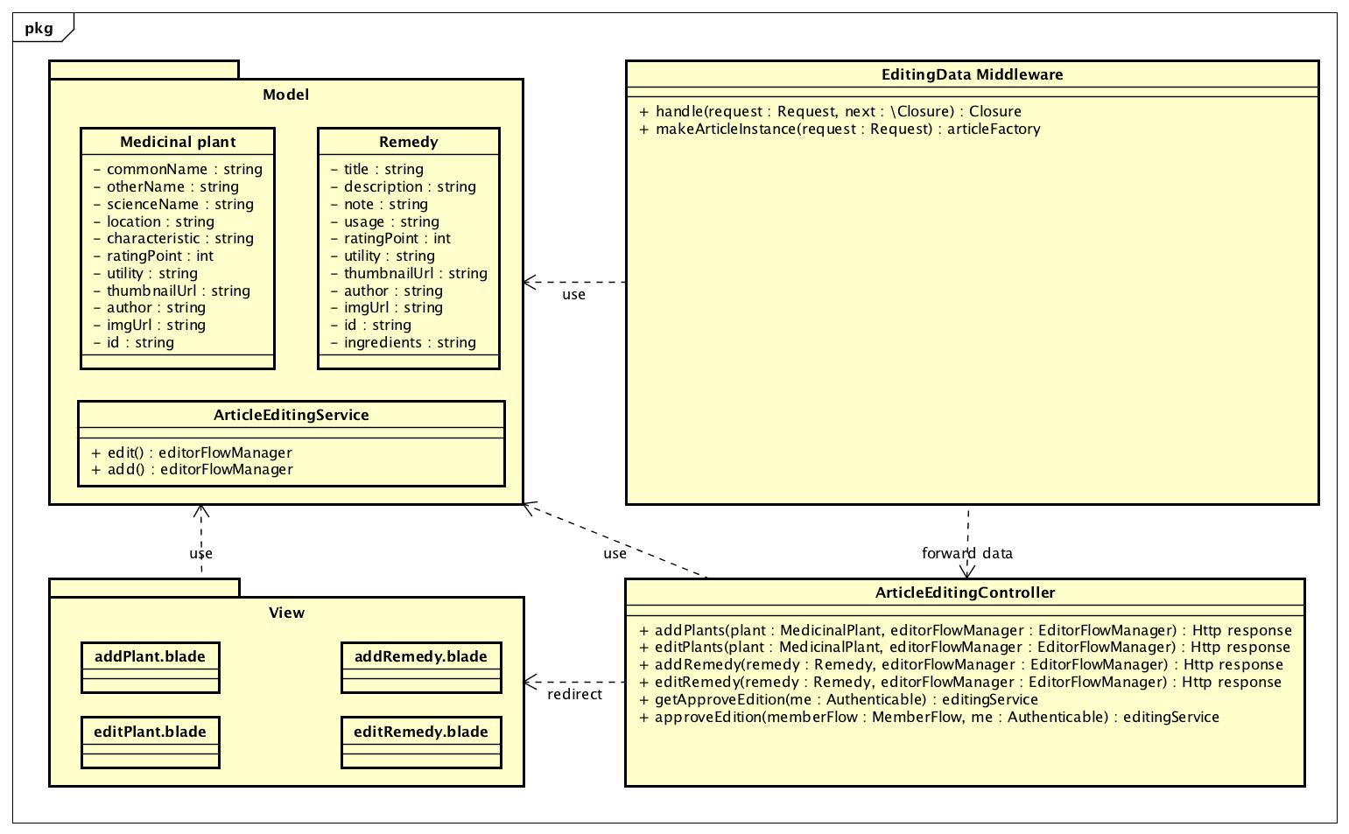

1. Contribute article class diagram

### Sequence Diagram of contribute article

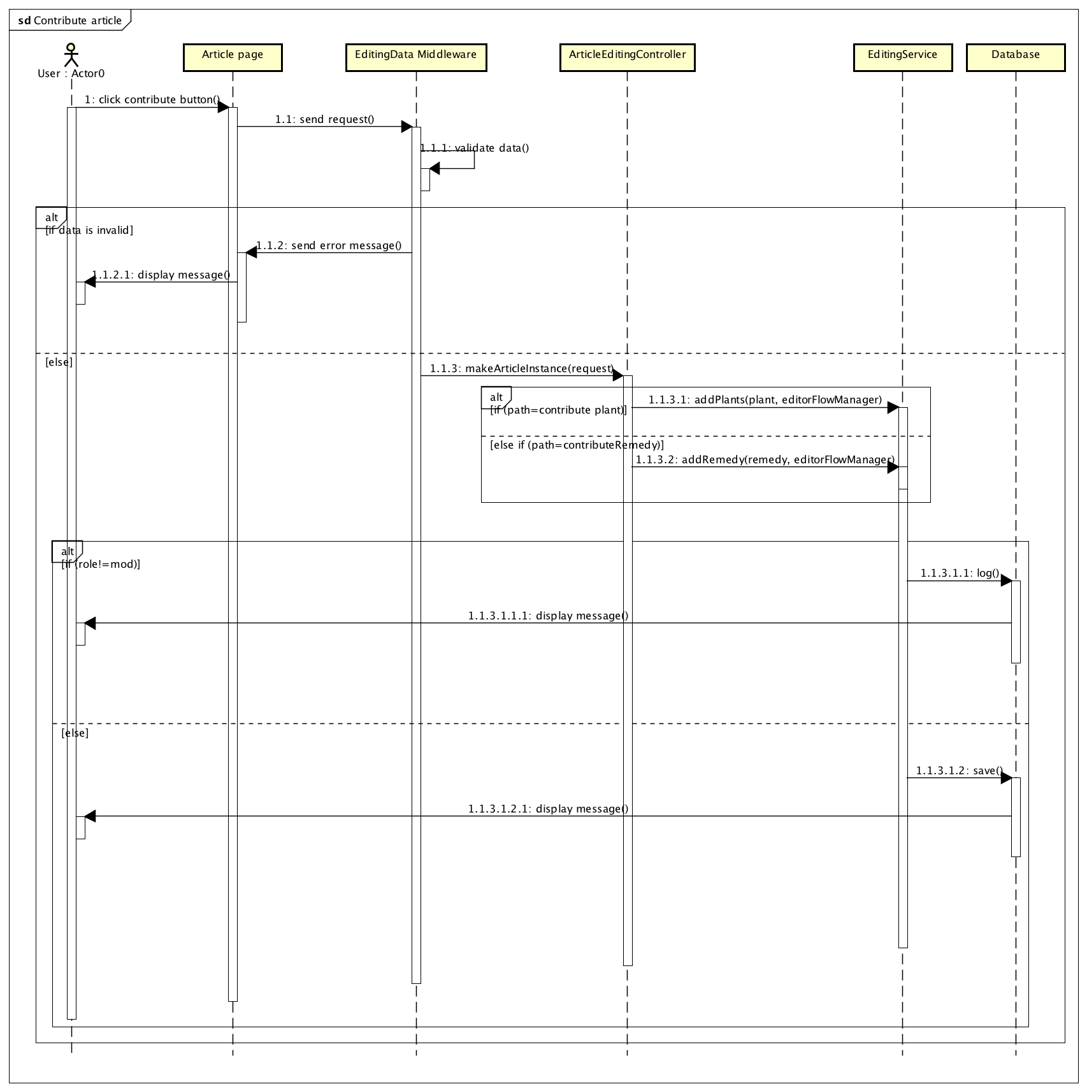

1. Contribute article sequence diagram

### Sequence Diagram of edit article

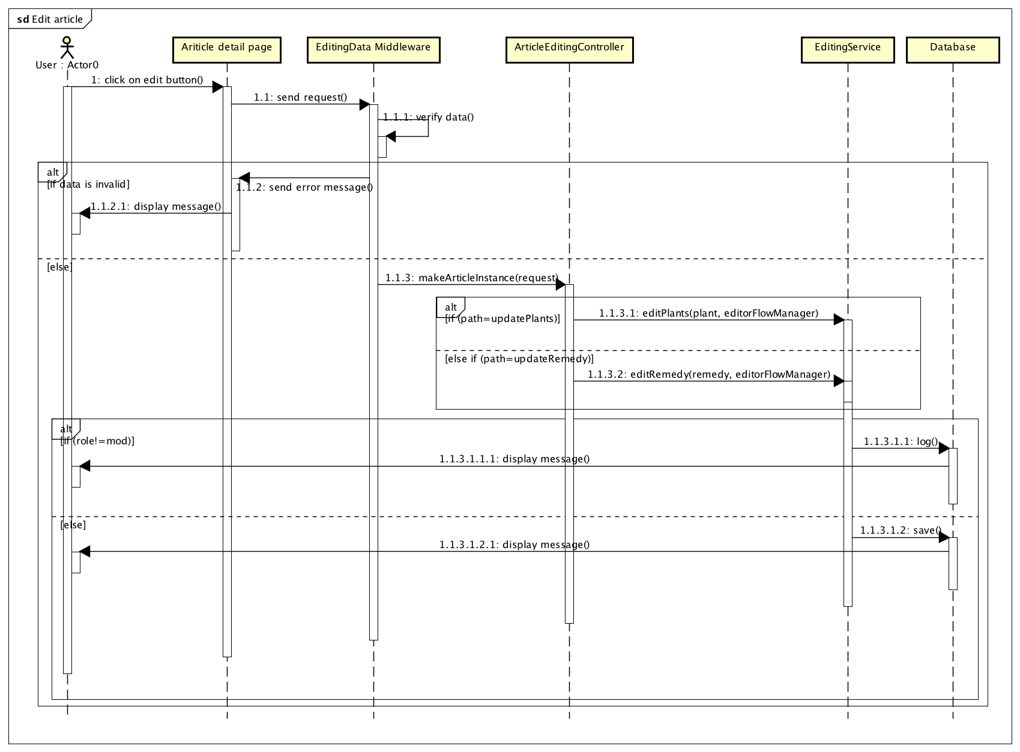

1. Edit article sequence diagram

## Report

### Class Diagram

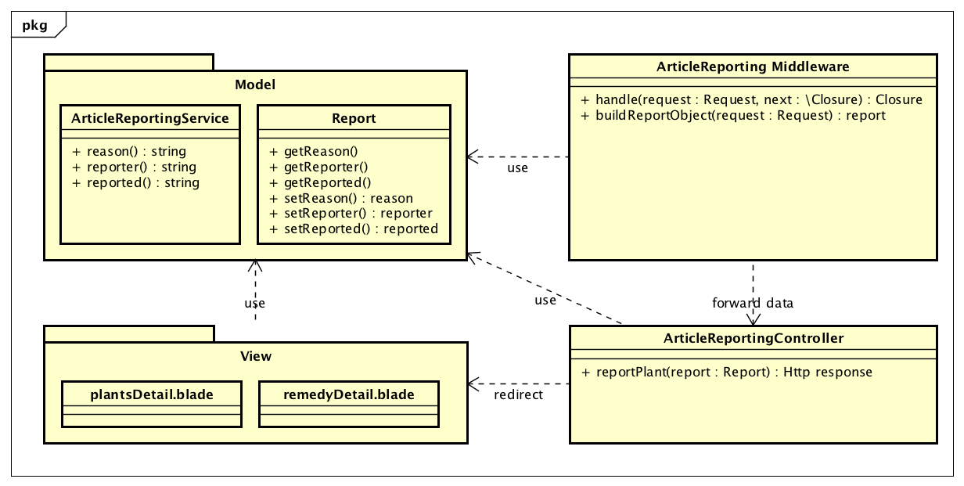

1. Report class diagram

### Sequence Diagram

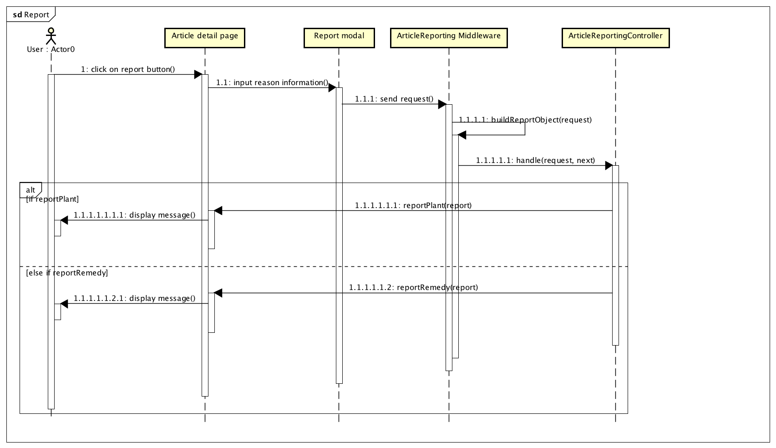

1. Report sequence diagram

## Review

### Class Diagram

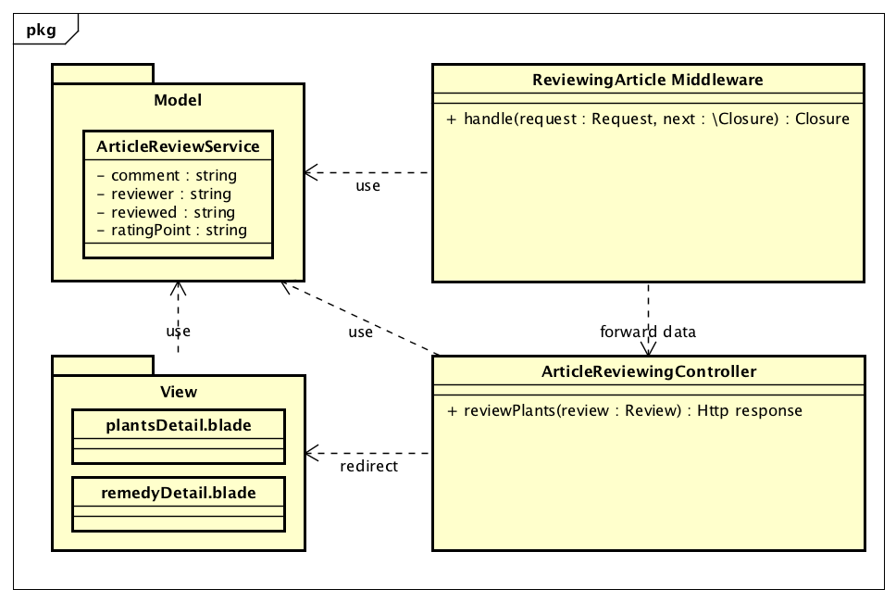

1. Review class diagram

### Sequence Diagram

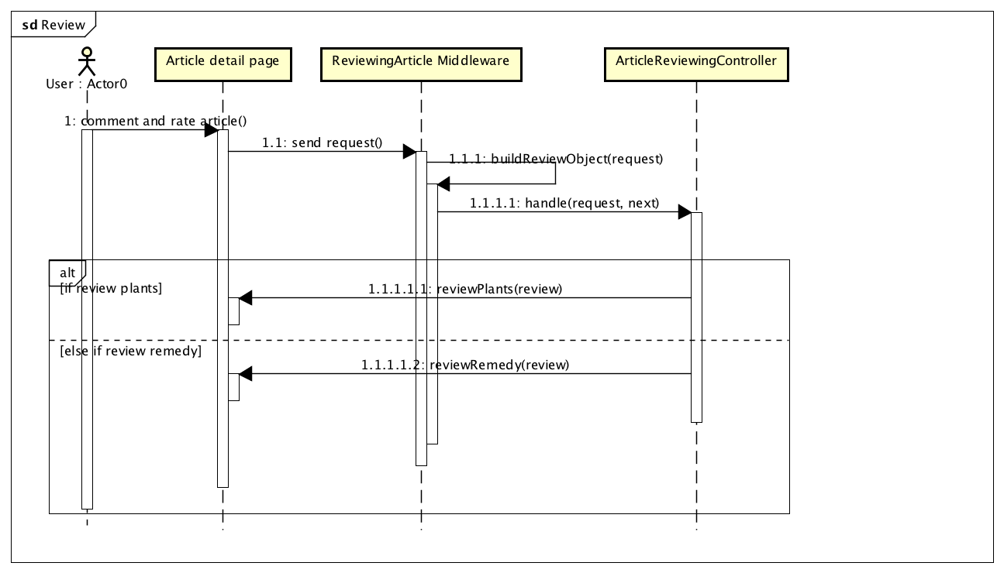

1. Review sequence diagram

## Admin Proceed

### Class Design

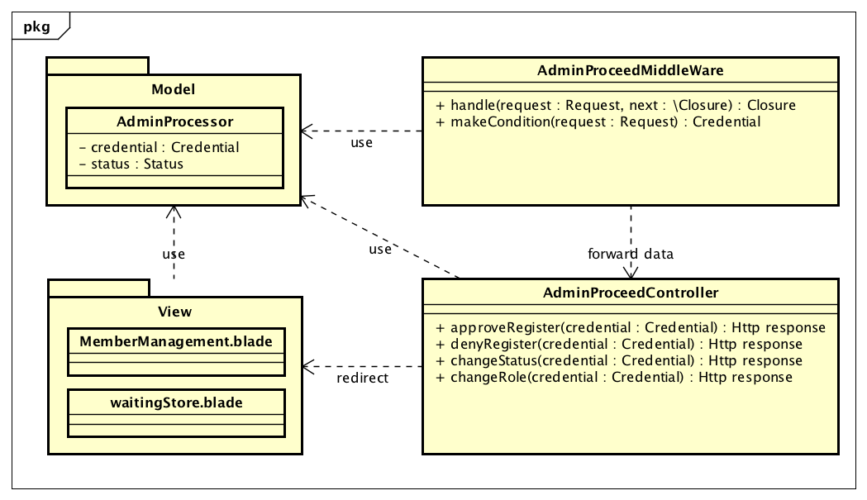

1. Admin class diagram

### Sequence Diagram

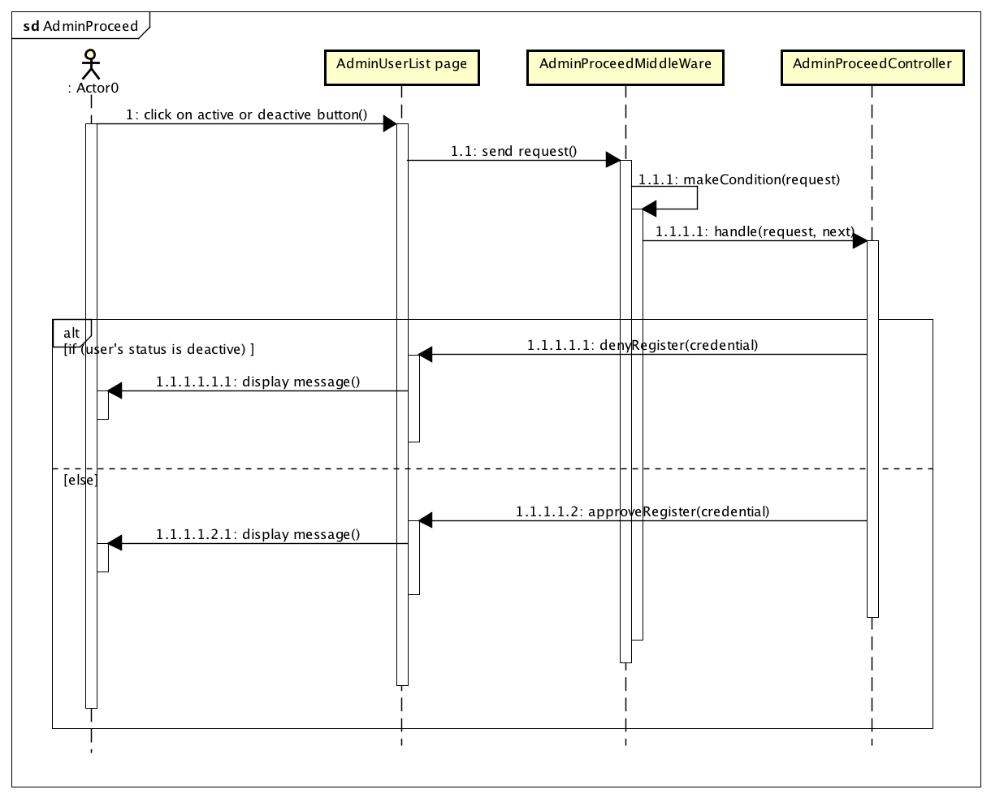

1. Admin Proceed sequence diagram

## Mod Proceed

### Class Design

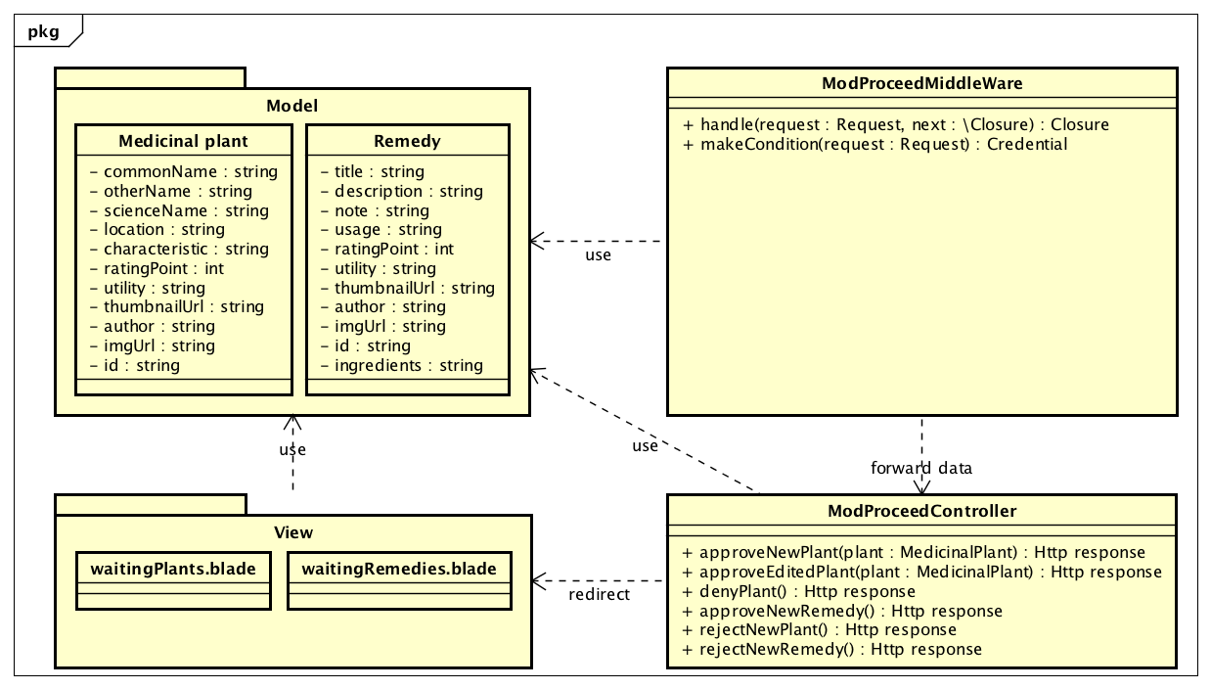

1. Mod proceed class diagram

### Sequence Diagram

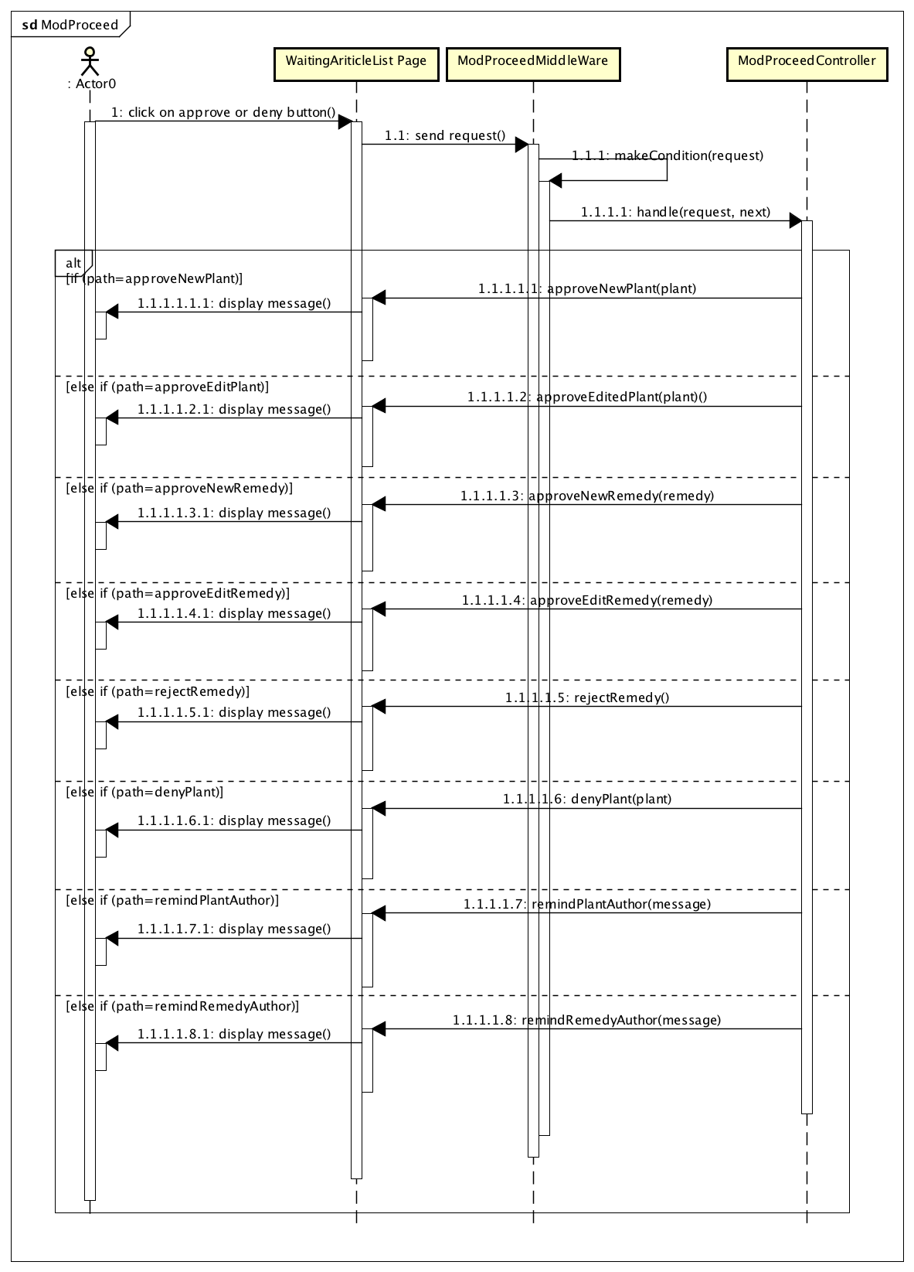

1. Mod Proceed sequence diagram